**Assignment – A5**

**UML Diagrams**

1. Use-case Diagram :

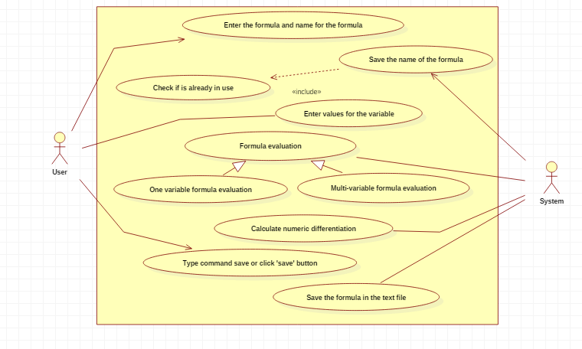

1. Activity Diagram:

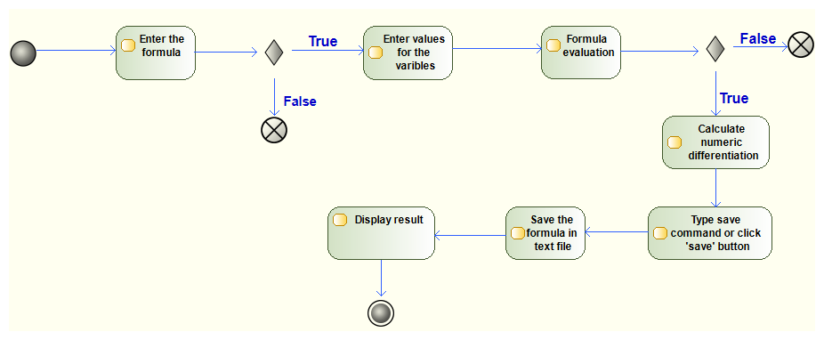

1. Sequence Diagram :

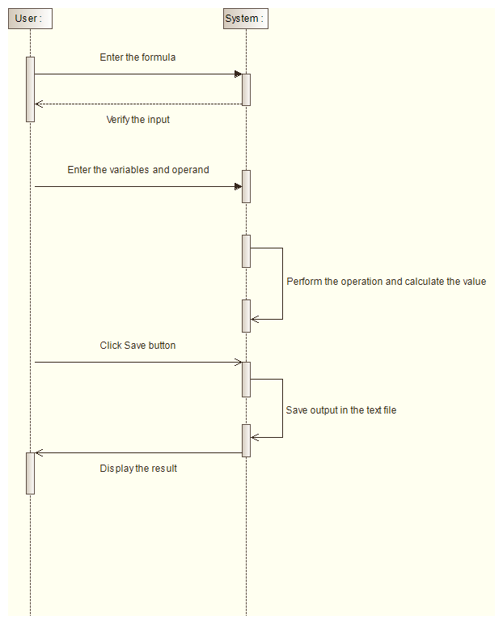

1. State Diagram :

